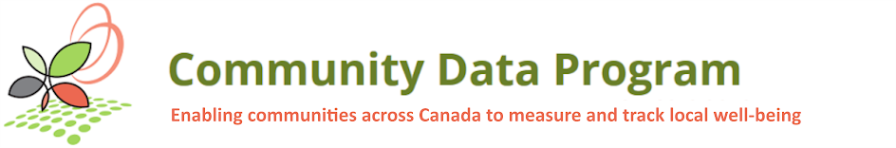
Training Capacity Building Working Groups meeting
Solutions Lab project
Meeting Date: | Tuesday, June 15, 2021 at 1:30 pm to 3:30 pm ET
Location: | Online: Zoom meeting room

Hosts & facilitators:
- Michel Frojmovic
- Mary Clarke
- John Purkis
- Davis Crenna
- Michael Ditor
- Saeideh Hejazi
- Sasha Mosky
- Bryn Ferris
Participants:
- Victoria Chapman – Simcoe County
- Tiffany Boeing – Simcoe County
- Ted Hildebrandt – Halton Region
- Andrea Dort – Region of Peel
- Albert Boakye – Social Planning Council of Winnipeg
- Roberta Jagoe – Region of Durham
- Emily Frauts – Hastings Prince Edward
- Laurie Dixon – City of Kingston
- Marci Pernica – Ontario Housing Data Group
- Prerna Bhasin – City of Toronto
Agenda:
- Welcome
- Where are we in the Solutions Lab?
- What is a prototype?
- What we heard from you - Seven priority clusters
  - Time for commentary from the group (World Café)
  - Feedback from the micro-labs
  - Voting on favorites
- Next Steps
  - Explore the feasibility of each of the prototypes directed by the National Lab
- Next Meeting
  - September 2021
  - Present the options for prototypes to develop
  - Oct to Dec is spent developing the prototype(s)

