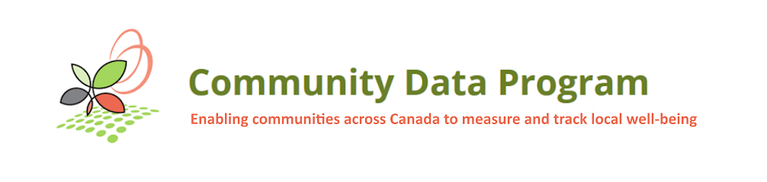
Community Data Solutions Lab
Developing easy-to-use community decision-making tools
to help achieve National Housing Strategy goals
Solutions Lab Working Group Meeting
Meeting Date: | Tuesday, January 12, 2021 at 1:30 pm to 3:00 pm ET
Location: | Online: Adobe Connect meeting room

Notes

Hosts:
- Michel Frojmovic
- Mary Clarke
- Michael Ditor

Presenters:
- David Crenna
- John Purkis
Participants:
- Aaron Mulcaster – Kawartha Lakes
- Bonnie-Anne Forbes – Province of New Brunswick
- Auburn Larose – North Bay Parry Sound Health Unit
- Albert Boakye – Social Planning Council of Winnipeg
- Kylee van der Poorten – City of Calgary
- Luke Grazier – City of Regina
- Raven Wheesk – Northern Policy Institute (NPI)
- Tiffany Boeing – County of Simcoe EDO
- Eric Campbell – Wellington-Dufferin-Guelph
- Jasmine lng – City of Calgary
- Laurie Dixon – City of Kingston
- Saeideh Hejazi – CDP
- Melissa Kelly – City of Calgary
- Prerna Bhasin – City of Toronto
- Ted Hildebrandt – Halton Region
- Victoria Chapman – Simcoe County

- Introduction (Mary - 5 mins)
- Overview of Solutions Lab (John Purkis - 30 mins) Different phases of this project and different roles that working group members can plan in the Solutions lab
- Questions (10 mins)
- Roundtable of possibilities that can be micro labs (Mary - 20 mins)
  - At most 6 micro labs in local level which mirror the process in National Solutions level
  - Do you like to lead a micro lab or be in the working group
  - Victoria Chapman Q: what time of commitment is needed for a micro lab? Certain amount of people and meetings? What are the possible outcomes of the micro lab? Like creating research data project?
Michel’s A: Starting point: picking up some momentum that already exist, question related to housing that needs data to answer it.
John’s A: 3-4 sessions at local level, a few sessions at national level.
Victoria’s Q: are we collecting data based on specific local need, develop a project that require that information, execute it and report it back?
Mary’s A: no data collection. Micro lab job: facilitating local people, project team discuss gaps in data, challenges in using housing data, what data you need and you can’t get. prototypes that come from us based on information you feeding back to us.
- Next steps (John - 5 mins): March 2nd: National insight generation workshop: review info gathered through research, Issues of use of data, …
- Follow up with Community Partners to enter into formal agreements before March 2nd
- Next meeting: Next Tuesday Jan19th: talk about housing landscape right now in Canada
- Findings on data and decision making (David Crenna - 20 mins)
- Housing issues considered relevant, significant by CDP members re: poverty reduction; community social development; effectiveness of solutions.
- Greater recent attention to data on homelessness, lack of affordable housing, seniors, mental health, visible minorities during COVID-19 pandemic.
- Multiple, varied applications of housing data by CDP members right now.
- Professional use of data by CDP already the norm… opening up opportunities for innovation, leverage.

