**Mapping TransUnion Data[1]**

**Introduction**

TransUnion data on Non-Mortgage Consumer Debt (NMCS) provide information on the number of individuals with non-mortgage consumer debt, the average and median of the debt and the associated risk and bankruptcy scores. The dataset for the first quarter of 2012 has more than 456,000 records. The data are available by Canada Post’s six-character postal code.

The postal codes are managed by Canada Post for the efficient sorting and delivery of mail. They are not created as units for the analysis or mapping of population, business or dwelling characteristics[2]. The six-character postal code (FSALDU) has two parts, (FSA – Forward Sortation Area and LDU – Local Delivery Unit). The LDU can be a single building or a range of addressed often associated with a postal carrier’s route or a set of post office boxes

Statistics Canada’s Postal Code Conversion File (PCCF) provides a linkage between the six- character postal codes and the standard Census geographic areas (municipalities, census tracts, dissemination areas, etc.). The consumer debt data grouped by geographic areas can be mapped and analyzed. The unique Enhanced PCCF file contains over 850,000 postal code points.

**Methodology**

The following describes the steps to process and map the NMCS data by standard Census geographic areas such as Census Tract (CT) and Dissemination Area (DA) using ESRI’s ArcGIS software. Of course, there are other ways to link the census geographies to the TransUnion data.

The Regional Municipality of Halton is used to illustrate the application of the methodology.

Step 1. Identify study area

The area of interest is the Regional Municipality of Halton in the GTA (Greater Toronto Area).

Step 2. Extract postal codes

Since the PCCF contains over 850,000 postal code points for the whole country, it is advisable to extract only postal codes within Halton Region for efficient data processing.

* Open PCCF in Microsoft Excel

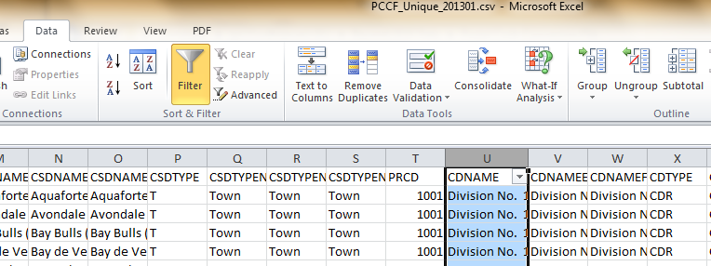

* Use the filter tool to extract postal codes for Halton Region which is also a Census Division (CD)
* click on column U (CDNAME)
* On the **Data** tab, in the **Sort & Filter** group, click **filter** to open dialogue box
* In the dialogue box, enter “Halton” to search for all postal codes in Halton
* 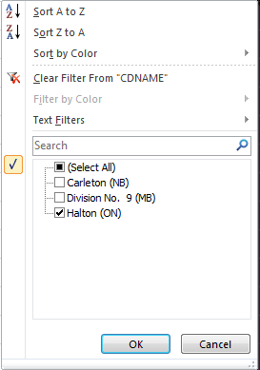Copy and paste the selected postal codes for Halton in a new Excel file (File_Halton Postal Code)
* Convert the CT and DA numbers into TEXT for subsequent joining the data file with the shape file
  + Click on the CT and DA columns
  + Right click > Format Cells
  + In the Format Cells dialogue box, choose **TEXT**
  + Click OK

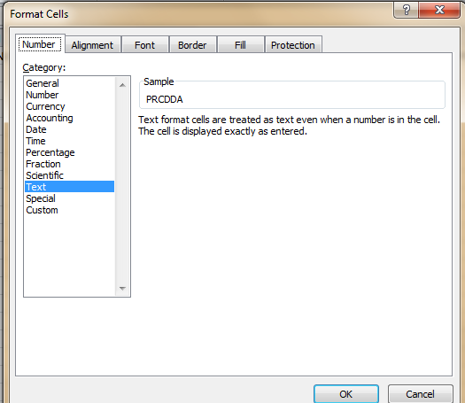

Step 3 Extract TransUnion records

* Similarly, use the filter tool to extract the TransUnion records for Halton Region
* From File_Halton Postal Code, note all the names of the communities (in column D - COMMNAME) – e.g. Acton, Burlington, Campbellville, Georgetown, Kilbride, Limehouse, Milton, Moffat, Norval, Oakville.

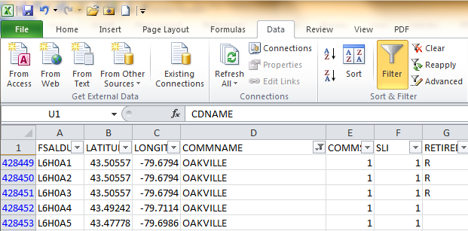

* From TransUnion Records, in the **filter** dialogue box, enter the names of all the communities for Halton Region by checking the appropriate boxes

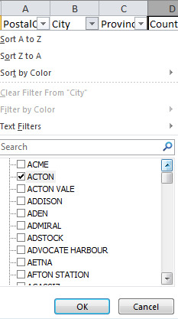

* Exclude community with same name but in different province (e.g. Burlington in Newfoundland)

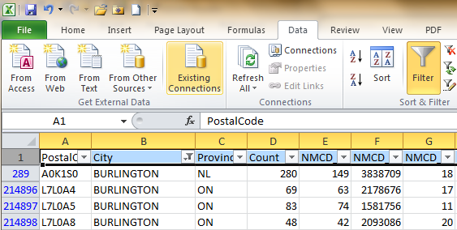

* Copy and paste the TransUnion records for Halton in a new Excel file (File_Halton TransUnion records)

Step 4 Join the two files

* Open ArcMap in ArcGIS
* Click **Add Data** button to add both files (File_Halton TransUnion records and File_Halton Postal Codes) to Table of Contents

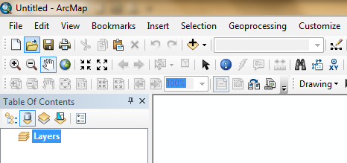

* Join the Halton_Postal Code File to the Halton_TransUnion records File
  + Highlight Halton_TransUnion records file in the Table of Contents
  + Right click > choose **Joins and Relates**
  + In Join Data dialogue box, enter “PostalCode” in box 1, the name of the postal code file in box 2
  + Enter “FSALDU” in box 3 – postal code column in the postal code file
  + Click “keep only matching records”
  + 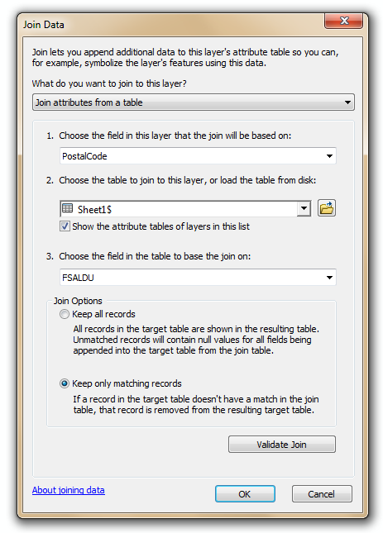Click OK
* Open Halton_TransUnion records file in the Table of Contents to see the joint table

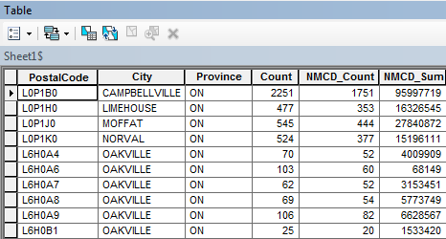

* 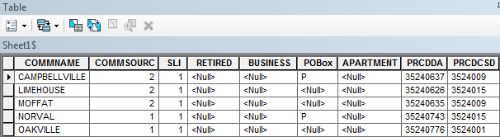Scroll across to see the contents of the Halton_Postal Code file (i.e. PRCDDA-Dissemination Area)

Step 5 Group postal codes into Dissemination Area

* The joint table shows a Dissemination Area (PRCDDA column) can have multiple postal codes

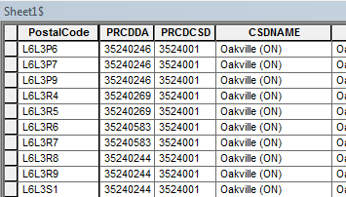

* Click at PRCDDA column to open a dialogue box
* Choose **Summarize** to group the postal codes into a Dissemination Area (DA)
  + Summarize – create a new table containing one record for each unique value of the selected field, along with statistics summarizing any of the other fields.
* Click on the name of the variable and choose “sum” to add all values
* A new table “Sum_Output” is created in the Table of Content and shows the TransUnion data by Dissemination Area (DA)
* Click OK

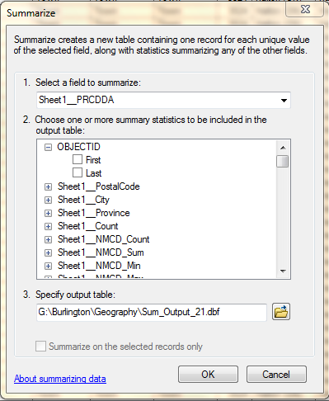

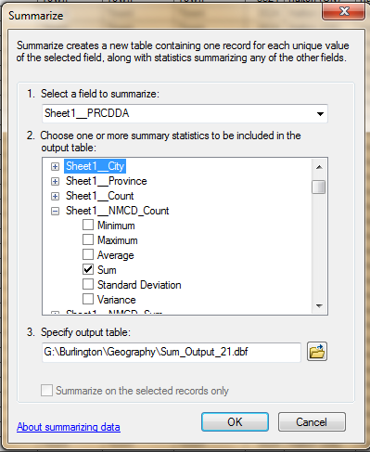

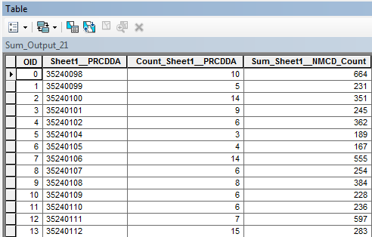

Step 6 Join table to Shape file

* Add Dissemination Area shape file to Table of Contents
* Join “Sum_Output” file to shape file
* Symbolize variable (s)
* Create map

Step 7 Create map by Census Tract

* Follow Step 5 to group DAs into Census Tract – using the **summarize** function
* Add Census Tract shape file to Table of Contents
* Join “Sum_Output” file to shape file
* Symbolize variable (s)
* Create map (see attached)

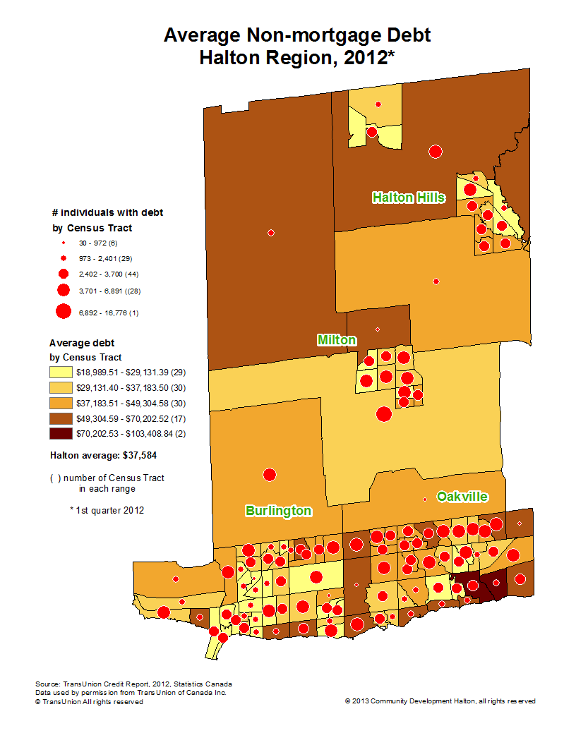

1. Prepared by Richard Lau, Research Associate, Community Development Halton
2. Statistics Canada, Research Paper, How Postal Codes Map to Geographic Areas, Catalogue no. 92F0123MIE-No.001