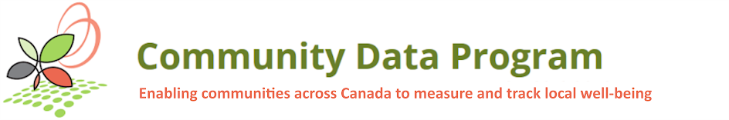

Community Data Solutions Lab
Developing easy-to-use community decision-making tools
to help achieve National Housing Strategy goals

Solutions Lab Working Group Terms of Reference
Project Background
The Community Data Solutions Lab is funded by the Solutions Lab Initiative of the Canada Mortgage and Housing Corporation (CMHC) to meet the goals of the National Housing Strategy (NHS).

About CMHC
CMHC is the Government of Canada’s National Housing Agency, with a mandate to help housing Canadians meet their housing needs. As Canada’s authority on housing, CMHC contributes to the stability of the housing market and financial system, provides support for Canadians in housing need, and offers objective housing research and advice to Canadian governments, consumers and the housing industry.

About the National Housing Strategy
Affordable housing is a cornerstone of inclusive communities. It helps to strengthen the middle class and grow the economy. Canada’s first-ever National Housing Strategy is a 10-year, $40-billion plan that will give more Canadians a place to call home and will create a new generation of housing in Canada. Through the NHS, the federal government is re-engaging in affordable housing and bringing together the public, private and non-profit sectors to ensure more Canadians have a place to call home. The goal of this historic strategy is to make sure Canadians across the country can access housing that meets their needs and that they can afford. To achieve this goal, the strategy will first focus on the most vulnerable Canadians.

About Solution Labs
The National Housing Strategy Solutions Labs initiative provides housing stakeholders with funding to help solve complex and persistent housing problems and foster innovation in the housing sector. Solutions Labs co-develop innovative, bottom-up solutions to specific problems that have not been able to be solved using traditional approaches. Solutions Labs funding focuses on:
  - resolving affordable housing problems within the NHS key priority areas and/or priority vulnerable populations;
  - targeting the rapid creation of solutions such as technologies, policies, programs or standards;
  - gathering a wide range of stakeholders, including those with lived experiences, to find solutions that are practical, replicable, implementable and deliverable within a realistic time frame;
  - requiring inclusion of Solutions (Social Innovation) Lab expertise to advise on the design and delivery of the lab to achieve the desired results; and
  - applying innovation lab tools and methods commonly used to solve persistent and complex affordable housing problems
About the Community Data Solutions Lab
Working in partnership with municipal and community sector organizations active in the housing sector, the Community Data Solutions Lab will strengthen evidence-based planning and decision making using innovative methods and tools to transform municipal and neighbourhood scale data into better programs, policies and operational decisions. These methods and tools will respond to the real constraints of time and analytical staff support needed to apply data to housing-related decisions affecting neighbourhoods and communities.
The figure below lays out a path forward from the current data and capacity gap facing housing professionals seeking to use data to make evidence based-decisions.
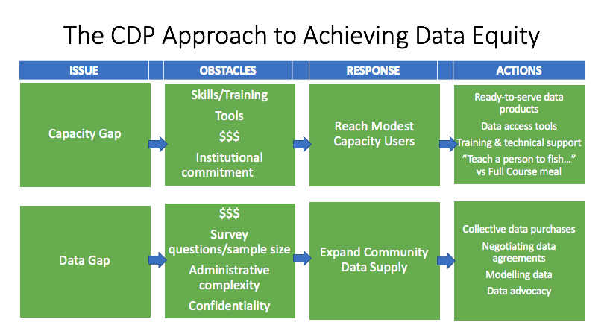
The project is being delivered over eighteen months, from October 1, 2020, until March 31, 2022, in the form of structured and facilitated workshops, webinars, tools development and testing, and technical guidance.

“Without strong, accessible data, decision-makers can’t make the best decisions to address housing supply issues. We have lots of housing data, but
- housing data is scattered, outdated, inconsistent, and not openly available
- Housing Data if full of gaps – especially for vulnerable populations
- Data collection limitations, which impacts availability, relevancy, timeliness
- Data sharing limitations – legal, business, other constraints limit sharing
- Data governance challenges – clear governance and standardization is lacking
- And other challenges!
Innovation can help raise awareness, explore solutions and improve decision-making.”
From CMHC

The project will be undertaken during the following phases:
Definition Phase  Oct-Nov 2020 | confirms which communities will host a succession of online solutions workshops. A larger networking group that includes participants in ongoing Solutions Labs will be invited to follow activities and contribute.
Discovery Phase  Dec 2020-Mar 2021 | will survey all CDP and CCEDNet members, plus interested Solutions Labs projects. They will be asked about the housing issues they encounter most frequently. A list of challenges and opportunities that need priority attention in workshops will be created based on the results.
Design Phase  Apr – Sep 2021 | involves convening a series of national and local online workshops to explore challenges and opportunities and prioritize potential solutions. Creative concepts and sample information products may also be produced. These will build on current good practices for data collection, analysis and communicating results to potential users.
Prototype and Test Phase  Oct- Dec 2021 | will test and refine phase 3 prototypes for new data sets, indicators, communication tools, stories and other ideas with user audiences. This will help to refine and improve results.
Roadmap Phase  Jan – Mar 2022 | will define a roll-out of the proposed new data sets, indicators, communication tools and stories over time. It will communicate a clear pathway for applying these tools and improving them.  Assessment activities will include a second online survey of the project network, and a roundtable with CMHC and Stats Canada experts to consider how lessons learned can be applied to the Housing Supply Challenge and future Solutions Labs.
Coordinating national and local (micro) level innovation
A national Solutions Lab hosted by the CDP and led by the project team will coordinate with a network of local “micro-labs” led by CDP members and supported by the national project team.
The National Solutions Lab will take the form of a CDP working group, relying on scheduled AdobeConnect meetings serving as training and learning workshops informed by a Solutions Lab innovation process.
Community Data Micro Labs will rely on member-led processes and will guide the preparation of project outputs to ensure their relevance to local trends and conditions.
Micro Labs will share certain core characteristics, including convening local stakeholders focused on the topic of housing and seeking to make better use of data to inform local decision making While each Micro Lab will be unique, they will be expected to align with the Solutions Lab problem statement, rely on the innovation methodologies provided by the Solutions Lab project team, and share reports and findings with the National Lab.
Community Data Solutions Lab Working Group Purpose
Like other CDP working groups, the Solutions Lab Working Group is an advisory and sounding board to CDP and the Project Team to inform and help steer the direction of the solutions lab process. As the success of the project rests significantly on the Project Team’s ability to engage people who work with housing data and other key stakeholders, the Working Group will also play an important role in providing leadership and access to their respective local networks to help mobilize stakeholder and provide feedback throughout the lab process.
The Working Group will be called upon to provide support, guidance and oversight on progress. Some individual members may also directly be responsible for managing and delivering project activities, such as a micro-lab, with the support of the Project Team. The Working Group is made up of the Project Team, Community Partners, and other stakeholders.
Community Data Solutions Lab Working Group Member Roles and Responsibilities
Project Administrator: Supports CDP through administration, contracts, and promotes the project to their network.
Project Team: provides leadership, oversight, partner engagement, governance, creation of tool, feedback to group, and reporting.

Community Partner: An organization already engaged in the CDP networks and committed to evidence-based decision making in support of housing policies and programs. Each Community Partner is participating in a local process aligned with Solutions Lab problem statement. This local process will serve as a Micro Lab working in parallel with the National Solutions Lab.
Collectively, all Community Partners shall participate in activities associated with the lab during different phases of the Solutions Lab:
- structured and facilitated workshops,
- webinars,
- tools development and testing,
- and technical guidance
Community Partners are expected to prepare for and attend National Solutions Lab working group meetings, to promote the project to their local network, provide feedback from local Micro Labs throughout the process, and provides insight and advice on the use of data to solve local housing problems
Other optional responsibilities could include the contribution of local data, policy or research, and/or assisting in communications and outreach for the project.
Other Stakeholder: members who are not community partners, including CDP members not participating in a local Micro Lab process, people with relevant expertise who may be invited to participate in occasional working group meetings, such as CMHC or StatsCAN. Other stakeholders will be provided updates on the project and will provide advice and feedback to the National Solutions Lab Working Group.
Community | Contact(s) | Project Role
CCEDNET | Michael Toye <mtoye@ccednet-rcdec.ca>; 'Melissa Lessard' <m.lessard@ccednet-rcdec.ca> | Project Administrator
Community Data Program | Michel Frojmovic michel@communitydata.ca; Mary Clarke mary@communitydata.ca; mike Ditor mike@communitydata.ca; Jamie Carrick jamie@communitydata.ca; Saeideh Hejazi saeideh@communitydata.ca | Project Team (Project management, coordination, data analysis, tool development)
Priority Decision Data | David Crenna <principal@prioritydecisiondata.com> | Project Team (Research)
Lansdowne Group | John Purkis jpurkis24@gmail.com; Fiona Wright <F.Wright@lansdowne.com> | Project Team (Solutions Lab Consultant)
CDEC de Québec, QC | Isabelle Gilbert, igilbert@cdecdequebec.qc.ca | Quebec Outreach and Micro lab facilitator
City Calgary, AB | Jasmine Ing Jasmine.Ing@calgary.ca; Melissa Kelly melissa.kelly@calgary.ca; Kylee van der Poorten Kylee.vanderPoorten@calgary.ca | Working Group Member; Micro lab convenor / Community Partner (TBC)
City of Kawartha Lakes, ON | Aaron Mulcaster amulcaster@city.kawarthalakes.on.ca; Janine Mitchell jmitchell@city.kawarthalakes.on.ca; mcorley@kawarthalakes.ca | Working Group Member
City of Kingston, ON | Laurie Dixon <ldixon@cityofkingston.ca> | Working Group Member; Micro lab convenor / Community Partner (TBC)
City of Peterborough, ON | Nancy Fischer <NFischer@peterborough.ca> | Working Group Member
City of Regina, SK | LGRAZIER@regina.ca | Working Group Member
City of Toronto, ON | Prerna.Bhasin@toronto.ca | Working Group Member
Winnipeg Social Planning Council, MB | Albert Boakye <aboakye@spcw.mb.ca> | Working Group Member; Micro lab convenor / Community Partner (TBC)
Canada Mortgage & Housing Corporation |  | Other Stakeholder
District of Muskoka, ON | Graham Good <Graham.Good@muskoka.on.ca> | Working Group Member
Halton Region, ON | Gena Ali gena.ali@halton.ca; Ted Hildebrandt thildebrandt@cdhalton.ca; Mike Nixon <mnixon@cdhalton.ca> | Working Group Member; Micro lab convenor / Community Partner (TBC)
Hastings County, ON | Beverley Bell-Rowbotham bell-rowbothamb@hastingscounty.com; Dino Marchiori <MarchioriD@hastingscounty.com> | Working Group Member; Micro lab convenor / Community Partner (TBC)
New Brunswick | John Calhoun John.Calhoun@gnb.ca; Bonnie-Anne Forbes bonnie-anne.forbes@gnb.ca | Working Group Member; Micro lab convenor / Community Partner (TBC)
North Bay-Parry Sound Health Unit, ON | Auburn Larose auburn.larose@healthunit.ca | Working Group Member
Northern Ontario | Rachel Rizzuto rrizzuto@northernpolicy.ca; Raven Wheesk <rwheesk@northernpolicy.ca> | Working Group Member
Nova Scotia | Rachel Brighton rbrighton@valleyren.ca; Chenlu Shao <Chenlu.Shao@novascotia.ca> | Working Group Member
Peel Region, ON | Andrea Dort <Andrea.Dort@peelregion.ca> | Working Group Member
Regional Municipality of Wood Buffalo. AB | Martin Byaruhanga <Martin.Byaruhanga@rmwb.ca> | Working Group Member
Simcoe County, ON | Kholah Nisar Kholah.Nisar@simcoe.ca; Victoria.Chapman@simcoe.ca; Tiffany Boening Tiffany.Boening@simcoe.ca; Irena Pozgaj <Irena.Pozgaj-Jones@simcoe.ca> | Working Group Member; Micro lab convenor / Community Partner (TBC)
Social Planning & Research Council (SPARC) BC | Lorraine Copas <lcopas@sparc.bc.ca> | Working Group Member
Statistics Canada |  | Other Stakeholder
Town of Banff, AB | Alison Gerrits <alison.gerrits@banff.ca> | Working Group Member; Micro lab convenor / Community Partner (TBC)
Waterloo Region, ON | Ross J Graham <RoGraham@regionofwaterloo.ca> | Working Group Member
Wellington Dufferin Guelph Public Health, ON | Eric Campbell Eric.Campbell@wdgpublichealth.ca | Working Group Member
York Region, ON | Natalie Hui <Natalie.Hui@york.ca> | Working Group Member
Benefits for Community Partners derived from participation
The project aims to integrate several innovations into the work of local planners, policy analysts, and decision-makers, including:
- Common indicators relevant to measuring housing results at the municipal and neighbourhood scale
- New data sources and uses of data, including data modeling
- Use of new software to support data visualization and data access
- Shared learning between provincial jurisdictions
- More effective feedback loops to better understand the impact of data on local decision making
Term
The term of the Working Group aligns with the Project schedule which is set to conclude by March 31, 2022.
Meetings
Frequency and Location: The Committee will meet approximately every two months. All meetings take place online at https://cdp.adobeconnect.com/theboardroom.
Logistics, Agenda and Notes: Meeting invitations, agendas, and minutes will be coordinated by CDP and the Project Manager from the Lansdowne Consulting Group with the input of all members. A page on communitydata.ca will be created and all Working Group Members will receive access in order to share project documents.
Financial Support: Community Partners can access a small grant to cover the costs of facilitation a Micro Lab such as the cost of a virtual meeting license or other technology tools. Grant requests should be made to michel@communitydata.ca.
Technology: A few different platforms will be used including Adobe connect, digital white board (Mural or Miro).
Schedule of meetings (all meetings occur on Tuesdays starting at 1:30 pm ET):
Date | Topic of Meeting
November 5, 2020 | Introduction to Solutions Lab Project
January 12, 2021 | Virtual orientation/training session for facilitators
March 2, 2020 | National insight generation workshop
April 6, 2021 | National level ideation session followed by microlabs engagement of local stakeholders ideation sessions
June 15, 2021 | National session to share ideas from local microlabs & confirm prototyping approach
September 14, 2021 | Prototyping activities workshop
November 9, 2021 | Check in
December 7, 2021 | Check in
February 8, 2022 | Lessons Learned Roundtable / Road map engagement session
March 8, 2022 | Sharing project results and transition to post-project implementation

Dates and times may change and people will be given as much notice as possible. Additional meetings may be added if needed.

The Community Data Program is an initiative of the Canadian Community Economic Development Network (CCEDNet), a national association of organizations and people throughout Canada committed to strengthening communities by creating economic opportunities that enhance social and environmental conditions.
The project entitled “Developing Easy-To-Use Community Decision-Making Tools To Help Achieve National Housing Strategy Goals” received funding from the National Housing Strategy under the NHS Solutions Labs.

