Please return your responses to:

Bethany Long, Aboriginal Liaison Advisor | Conseiller de Liaison Autochtone
Statistics Canada | Statistique Canada
Suite 400, 10025 Jasper Ave, ATB North Tower
Edmonton, AB T5J 1S6
Ph (780) 495-4009 | Fx (780) 495-2614
bethany.long@canada.ca
Regional Discussions
Statistics Canada will be holding discussions across Canada seeking input from data users, stakeholders and Aboriginal people to review the Aboriginal identification questions used in the Census and other surveys.

This discussion is a first step in the process to review the questions used by Statistics Canada to produce data about First Nations people, Inuit and Métis from the Census. Question reviews are undertaken periodically to ensure that definitions and terminology are still relevant.

Your feedback is important and will greatly assist Statistics Canada with this endeavor.

The objectives of this session are to:
- introduce data collected by Statistics Canada on First Nations people, Métis and Inuit
- review Aboriginal identification questions and concepts used at Statistics Canada
- discuss concerns about existing questions (terminology, placement) and definitions, and obtain input on possible changes or new questions
- discuss your data needs and /or how you use Aboriginal data
- obtain your feedback on outreach products used by Statistics Canada’s Aboriginal Liaison Program

Your input will help us to better understand how people may react to the questions and how they may be interpreted.
Name:
Organization:
Address:

Email:
Phone:
Participant Notes
(Non-facilitated & Self-administered)

Regional Discussions
Aboriginal Identification Questions in the Census and Other Surveys
Fall 2017

After seeing the presentation that outlines the questions used by Statistics Canada to identify First Nations people, Inuit and Métis, we’d like to get your impressions. This presentation should have been sent to you in a separate document. Please go through each question and provide your feedback.

Question on “Aboriginal Group”

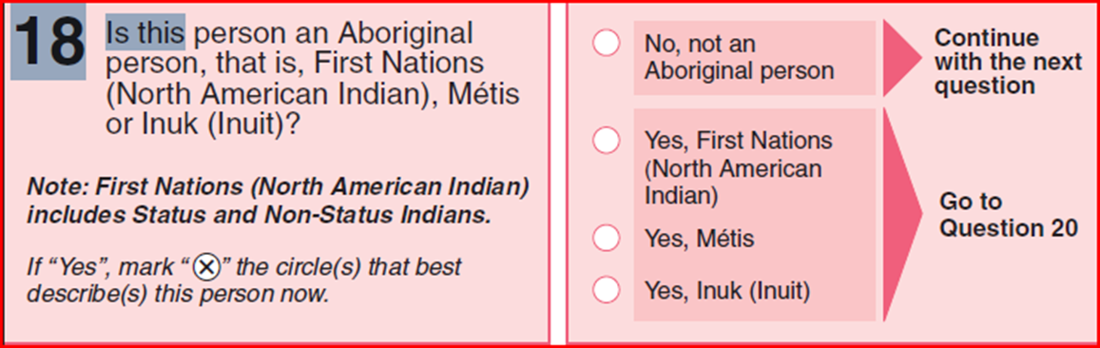

This question asks whether people identify as Aboriginal and with which of the three Aboriginal peoples recognized in the Constitution they identify themselves.

- What do you think of this question?

  - How do you think people may react to this question?

  - Do you think this question accurately identifies First Nations people, Inuit and Métis?

  - Do you think some people may be missed or that some may misunderstand or be misled? (How? Who?)

- How do you feel about the terms used?

  - How about the term “Aboriginal”?

  - How about using the terms “North American Indian”,” Métis” and “Inuk(Inuit)”?

  - Are there other terms we should consider?

- Do you feel it is necessary to include the note on First Nations including status and non-status Indians? Please explain your answer.

- Are there any other comments on this question?

Question on “Registered or Treaty Indian Status”

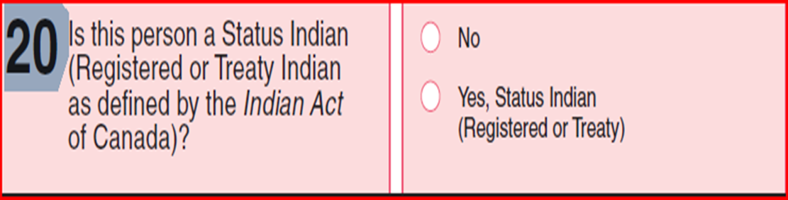

- What do you think of this question?

  - How do you think people may react to this question?

  - Do you think some people may be missed or that some may misunderstand or be misled? (How? Who?)

- How do you feel about the terms used?

  - How about the term “Status Indian”?

  - How about using the terms “Registered”, “Treaty Indian”?

  - Are there other terms we should consider?

- Are there any other comments on this question?

Question on “Membership in a First Nation or Indian Band”

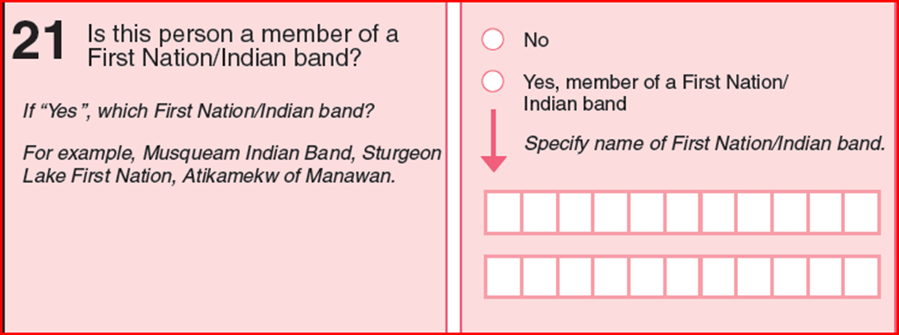

- What do you think of this question?

  - How do you think people may react to this question?

  - Do you think some people may be missed or that some may misunderstand or be misled? (How? Who?)

- How do you feel about the terms used?

- How about using the terms “First Nation”, “Indian Band”?

- Are there other terms we should consider?

- And what do think of the examples used?

  - Are they helpful?

  - Do they cover the various ways of naming First Nations?

- Are there any other comments on this question?

Questions on “Ethnic Origin and Aboriginal Ancestry”

On the 2A-R
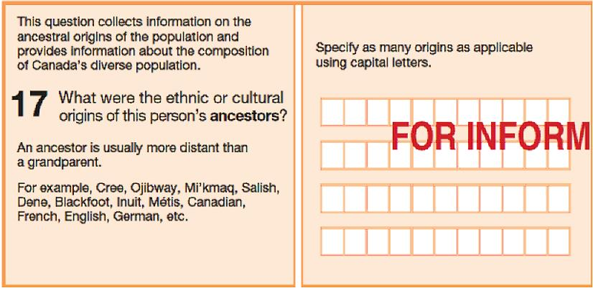

On the 2A-L
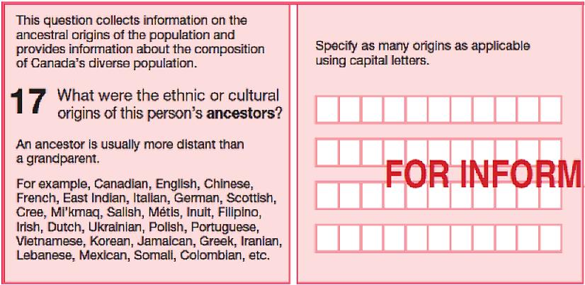

These questions ask about the origins of a person’s ancestors. The two questions are the same but the examples of origins provided differ. They are used on two slightly different Census long forms.

The first question is from the 2A-R questionnaire that is used in northern and First Nation communities. It contains the census long-form questions with examples that are more relevant to these communities. In these areas, the census is done by personal, face-to-face interviews with respondents.

- What do you think of this question?

  - How do you think people may react to this question?

  - Do you think some people may be missed or that some may misunderstand or be misled? (How? Who?)

- How about the examples? (Aboriginal examples are Cree, Ojibway, Mi’kmaq, Salish, Dene, Blackfoot, Inuit, Métis)

- Do they provide a good overview of the various Aboriginal origins?

The second question is from the 2A-L questionnaire used in all other areas (southern small and large urban areas and rural communities) and is completed by the respondent (self-administered).

- What do you think of the examples for this question? (Aboriginal examples are Cree, Mi’kmaq, Métis, Inuit)

  - Do you think some people may be missed or that some may misunderstand or be misled? (How? Who?)

- Are there any other comments on these two questions?

Other Ideas

Now that we’ve talked about each of the questions, we’d like to find out…

- What are your thoughts on the use of the terms Aboriginal and Indigenous?

- If you were impacted by recent court decisions such as the Daniels Decision or Qalipu, think about how these decisions would affect your answers to the above questions? Please explain your answer.

Note regarding Daniels Decision:
Daniels v. Canada (Indian Affairs and Northern Development)

The ruling in the Daniels case, says that Métis and non-status Indians are “Indians” under section 91(24) of the Constitution Act, 1867 which means they now fall under the federal government’s jurisdiction.

Thank you for your comments and your time!

