Chart Design Checklist

Text.
Text is your friend. Use it to draw your reader in and point out key trends.

- Consult our Agency Guidelines. Only use Agency fonts when creating charts.
- Use a chart title to describe the key trend in your visual (6-12 words). Avoid a generic title. Left-align the title in the upper left corner of your chart.
- Consider using a subtitle to provide any additional key information.
- Annotate your chart to point out key messages. Don’t assume that two different people looking at the same chart will come to the same conclusion.
- Label the titles of your x- and y-axis if your chart has them.
- Don’t include both axis labels and data labels – choose one or the other.
- Text should be hierarchical. Titles are a larger font than subtitles or annotations, which are larger than labels, which are larger than axis labels, which are larger than source information. The smallest text – axis labels – are at least 9 point font size on paper, at least 20 on screen.
- Text should be horizontal. If the axis labels on your x-axis are slanted or diagonal, shorten the labels or change the chart type. Note: y-axis title will always be vertical.
- Use straightforward language. Choose simple language over complex. Choose fewer words over more words. Define any specialized language that your audience may not know. Spell out acronyms.
- Use text size, italics, bold, underline and spatial separation to draw attention to a particular part of the chart or text around it.

Colour.
Be smart with colour. The use of colour should always be an intentional decision. Use colour sparingly and strategically to highlight the important parts of your visual.

- Consult our Agency Guidelines. Use Agency colours when creating visuals on behalf of Public Health.
- Use colour to accentuate key numbers, bars, pie slices, dots, or lines in your chart. Use the same colours to accentuate key words around your chart. Gray out all other parts of your graph and corresponding text.
- Colour is distinguishable when printed in black and white. This is an important consideration for both accessibility and dissemination.
- Make sure your visual is accessible to colour blind people (e.g. don’t use red and green only and consider using symbols or textures to help with accessiblity).

Eliminate distractions.
Consider what is critical to display and what is not critical. Identify unnecessary, extraneous or irrelevant items and remove them from your graph. When detail isn’t needed, summarize. Ask yourself, would eliminating this change anything? If not, remove it. Push necessary, but non-message-impacting items to the back (using gray works well for this).

- Remove graph border.
- Remove or gray out gridlines, unless they help with interpretation.
- Remove or gray out the numerical axis. If it’s a horizontal or vertical bar graph, use data labels on the bars directly. You can also add data labels to pie charts, slopegraphs, dot plots, and clustered bar graphs.
- Consider removing the categorical axis. If it’s a horizontal or vertical bar graph, use category labels on the bars directly. You can also add category labels to slopegraphs, line charts, pie charts and key points on scatter, dot, or bubble plots.
- Consider removing legends. Label the bars, lines, pie slices, or dots are directly. Alternatively, you can use colours in the chart title to show labels (see the Dot Plot example in the Chart Chooser).
- Avoid special effects on bars and lines such as 3D, shadows, or transitional shading.
- Avoid unnecessary tick marks on your axis.
- Consider the precision that is required for your data values. Does your audience only need to see a rounded number (e.g. 45%) or does it need to see decimal points (e.g., 45.1% or 45.5%)? Don’t clutter your charts with unnecessary numbers.

Arrangement.
Improper arrangement of graph elements can confuse or mislead your reader. A thoughtful layout makes the visual easier for your reader to interpret.

- Where possible, avoid charts that rely on an individual’s perception of area (e.g., pie/donut chart), volume (e.g., 3D chart), or curvature (e.g., curved bar graph). Human eyes have a difficult time accurately interpreting these.
- Pay attention to the alignment of your visuals and text on a page. Organize elements on the page to create clean vertical and horizontal lines to establish a sense of unity and cohesion. Left alignment is your friend.
- White space is also your friend. Don’t cram your visual with items just because you can. White space makes a chart easier to read and more visually appealing. Don’t stretch your graphics to fill the space or simply add things because there is extra space.
- Order data appropriately. Time should be on the x-axis and read from left to right (e.g., Jan, Feb, Mar…). If your chart doesn’t show time, data should be arranged from largest to smallest or vice versa.
- Be careful of truncating axes of bar chart. An axis should always start at zero.
- For bar charts, spaces between bars should be about half the bar width.
- Make sure to use consistent intervals and spacing on your x- and y-axis when presenting numerical data.

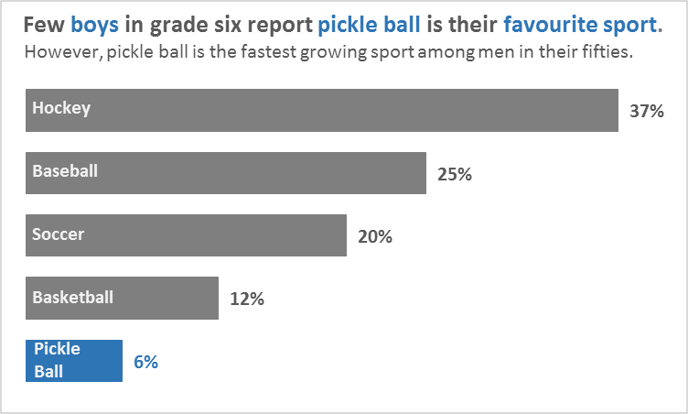
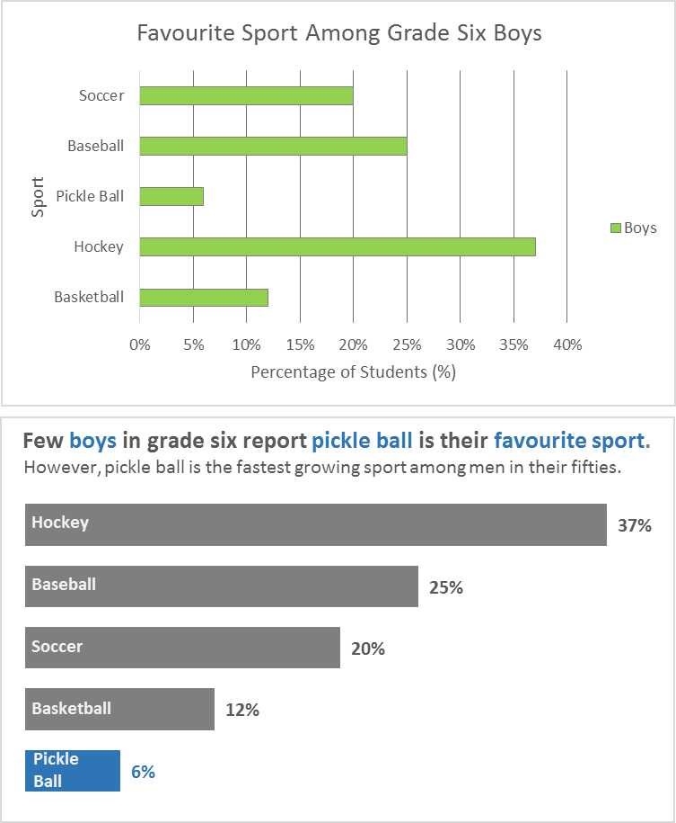
Sample Charts Before and After Visualization with Labels
Category Label
Generic Chart Title
Chart Border
Gridlines
Legend
Axis Label
Axis Title
y-axis
x-axis
After
Action Colour
Descriptive Chart Title
Subtitle
Data Label
Before

